**LAB ASSIGNMENT-05**

Aim: To create C programs for the different scheduling algorithms.

To perform: Create and execute C programs for following CPU Scheduling Algorithms:

1. First Come First Serve (FCFS)

2. Shortest Job First (SJF)

3. Round Robin Scheduling

IM PERFORMING C++ CODES ->>>

1. First Come First Serve (FCFS)

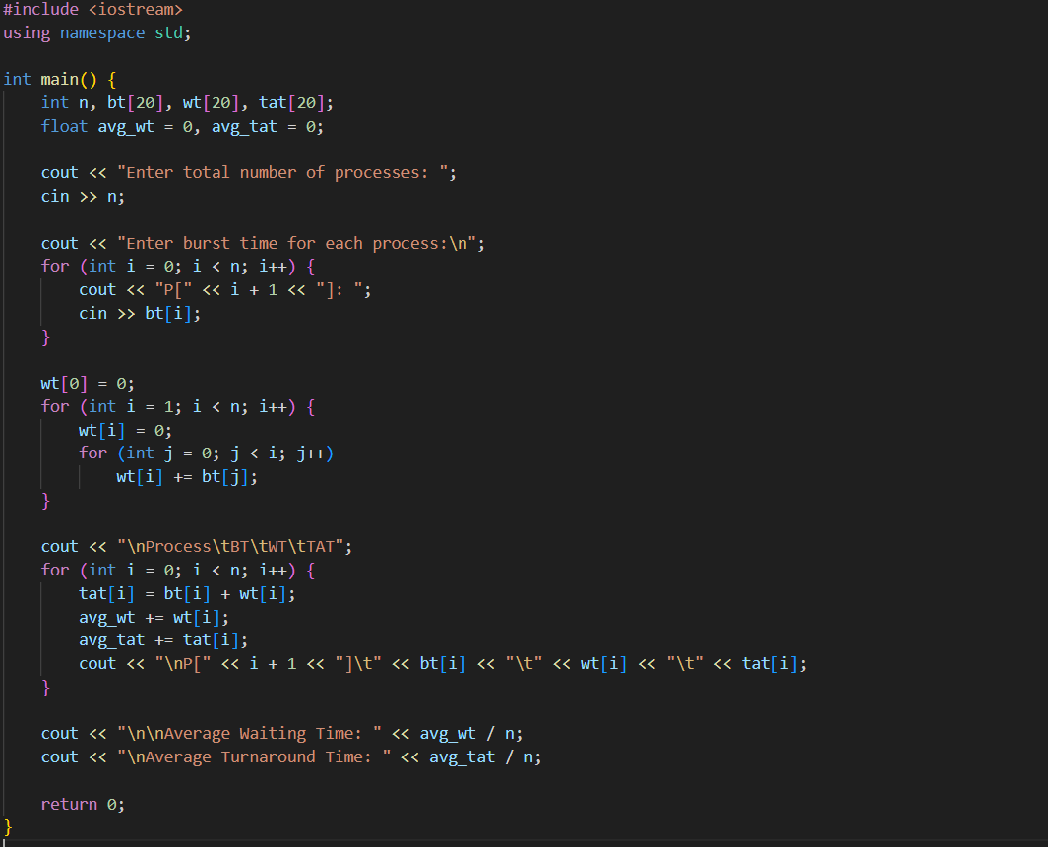

OUTPUT-

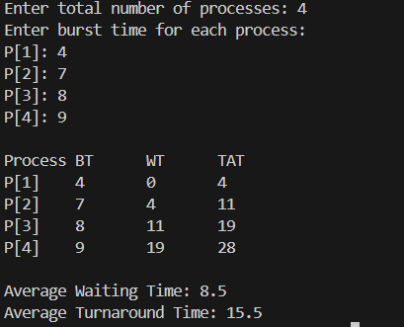

1. Shortest Job First (SJF)

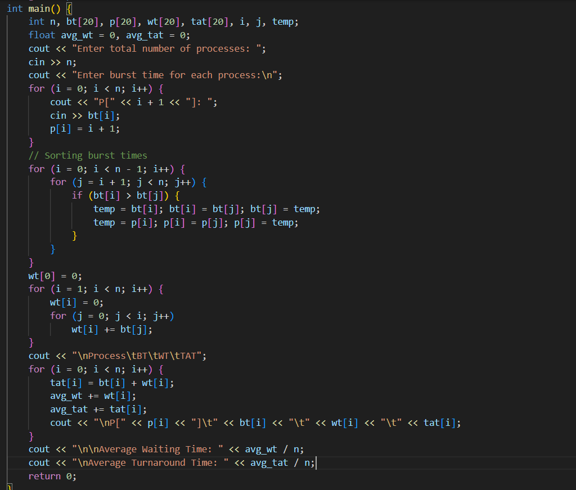

OUTPUT-

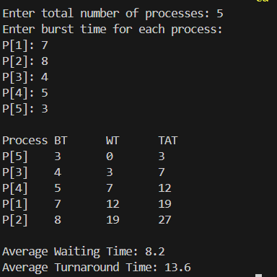

3. Round Robin Scheduling

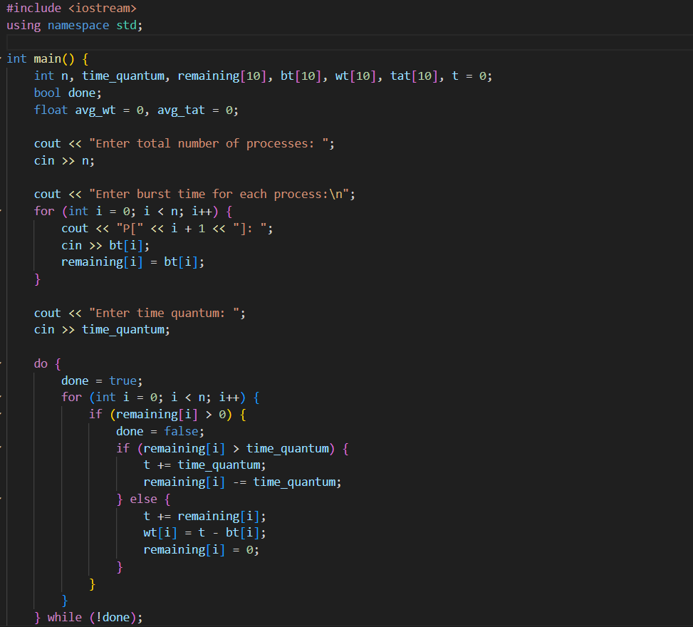

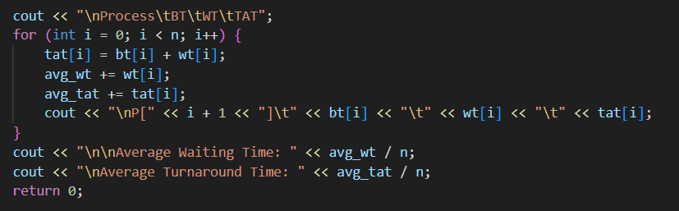

OUTPUT-

